Peter Sherman
AE6009 – Viscous Fluid Flow
Homework #2

Part A). Description of the equation and solution process
To solve the stagnation point flow problem, this program solves the following ODE:
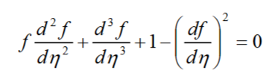
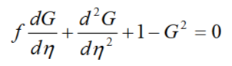
By using an intermediate variable G where,
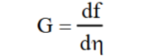

In practice, first, a grid of N points is initialized. The spacing between these points increases by 1.1x from 0 to N given by
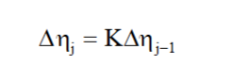
Next, an array of size N is initialized with our initial guess of G such that G(0) = 0, G(1$→$N) = 1
Since G = df/dn, we can solve for f array using the following equation:
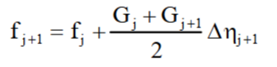
Now to approximate the ODE, the function must be approximated at N points in a system of linear equation using a central difference method.
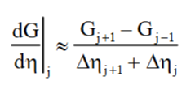
The system of linear equations follow this formulation:
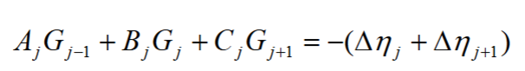
Where,
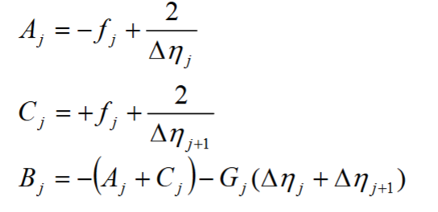
These values are assembled into a matrix to solve the equation MG = RHS:
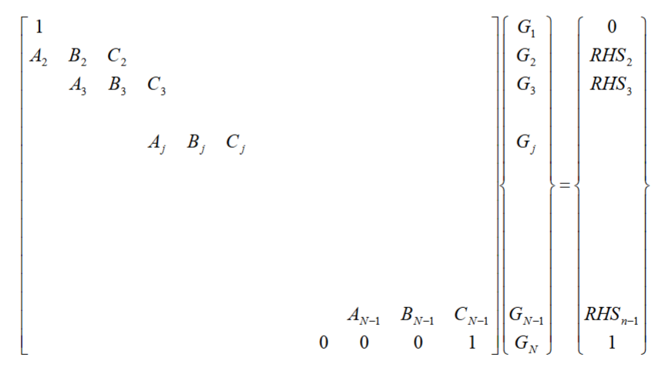
Where,
$${RHS}_{j} = -(∆n_{j}+∆n_{j+1})$$
Finally, solve for G using $G = M({RHS}^{-1})$. This gives an approximation for G, so to increase accuracy, it is important to iteratate this procedure by comparing the old G to the computed G to minimize error.

Part 2). Listing of the Computer Program
%step 1: Selection of points between eta = 0 and eta > 10;
N = 40;
K = 1.1;
ETA = zeros(N, 1);
deltaETA = zeros(N, 1);
deltaETA(2) = 0.02;

for j = 3:N
deltaETA(j) = K * deltaETA(j - 1);
end

for j = 2:N
ETA(j) = ETA(j-1) + deltaETA(j);
end

%step 2: Initilizing the G vector
G = ones(40, 1);
G(1) = 0;

%iterating to converge G
error = Inf;
while error > 1e-3

oldG = G;

%step 3: Computing f from G
f = zeros(N, 1);
for j = 1:N-1
f(j+1) = f(j) + (1/2) * (G(j) + G(j+1)) * deltaETA(j+1);
end

%step 4: discretization of G dif-e
A = zeros(N-1, 1);
B = zeros(N, 1);
C = zeros(N-1, 1);

for j = 2:N-1
A(j-1) = -f(j) + 2 / (deltaETA(j));
C(j) = f(j) + 2 / (deltaETA(j+1));
B(j) = -(A(j-1) + C(j)) - G(j) * (deltaETA(j) + deltaETA(j+1));
end

%step 5: Solve the tridiagonal system Ax = b
M = diag(B) + diag(A, -1) + diag(C, 1);
M(1, :) = 0;
M(1, 1) = 1;
M(end, :) = 0;
M(end, end) = 1;

%step 6: apply boundary conditions
RHS = zeros(N,1);
for j = 2:N-1
RHS(j) = - (deltaETA(j) + deltaETA(j+1));
end
RHS(N) = 1;

%step 7: solve system of equations
G = M \ RHS;

error = max(abs(G - oldG));
end

Part C). Table comparing the output to known solution
η | Expected f | Computed f | f Error (%) | Expected G | Computed G | G Error (%)
0.0 | 0.000000 | 0.000000 | N/A | 0.000000 | -6.6614e-16 | N/A
0.1 | 0.005996 | 0.0060882 | 1.538 | 0.118265 | 0.11823 | 0.030
0.2 | 0.023322 | 0.023488 | 0.712 | 0.226612 | 0.22655 | 0.027
0.3 | 0.050995 | 0.051280 | 0.559 | 0.325241 | 0.32510 | 0.043
0.4 | 0.088057 | 0.088462 | 0.460 | 0.414456 | 0.41423 | 0.055
0.5 | 0.133585 | 0.133890 | 0.228 | 0.494649 | 0.49458 | 0.014
0.6 | 0.186701 | 0.187320 | 0.332 | 0.566281 | 0.56589 | 0.069
0.7 | 0.246573 | 0.247110 | 0.218 | 0.629861 | 0.62960 | 0.041
0.8 | 0.312423 | 0.312870 | 0.143 | 0.685937 | 0.68583 | 0.016
0.9 | 0.383529 | 0.384030 | 0.131 | 0.735079 | 0.73494 | 0.019
1.0 | 0.459227 | 0.459940 | 0.155 | 0.777865 | 0.77747 | 0.051
1.1 | 0.538910 | 0.539860 | 0.176 | 0.814873 | 0.81416 | 0.087
1.2 | 0.622028 | 0.623040 | 0.163 | 0.846671 | 0.84587 | 0.095
1.3 | 0.708089 | 0.708810 | 0.102 | 0.873808 | 0.87350 | 0.035
1.4 | 0.796652 | 0.797490 | 0.105 | 0.896809 | 0.89637 | 0.049
1.5 | 0.887329 | 0.888410 | 0.122 | 0.916168 | 0.91533 | 0.091
1.6 | 0.979779 | 0.980430 | 0.066 | 0.932348 | 0.93234 | 0.001
1.7 | 1.073710 | 1.074800 | 0.102 | 0.945774 | 0.94504 | 0.078
1.8 | 1.168860 | 1.169700 | 0.072 | 0.956834 | 0.95656 | 0.029
1.9 | 1.265010 | 1.266000 | 0.078 | 0.965877 | 0.96530 | 0.060
2.0 | 1.361970 | 1.362800 | 0.061 | 0.973217 | 0.97301 | 0.021
2.1 | 1.459600 | 1.460600 | 0.069 | 0.979128 | 0.97863 | 0.051
2.2 | 1.557760 | 1.558600 | 0.054 | 0.983853 | 0.98388 | 0.003
2.3 | 1.656340 | 1.657400 | 0.064 | 0.987601 | 0.98721 | 0.040
2.4 | 1.755250 | 1.756100 | 0.048 | 0.990549 | 0.99054 | 0.001
2.5 | 1.854430 | 1.855400 | 0.052 | 0.992851 | 0.99267 | 0.018
2.6 | 1.953810 | 1.954800 | 0.051 | 0.994634 | 0.99445 | 0.018
2.7 | 2.053340 | 2.054200 | 0.042 | 0.996003 | 0.99609 | 0.009
2.8 | 2.153000 | 2.154000 | 0.046 | 0.997046 | 0.99693 | 0.012
2.9 | 2.252740 | 2.253700 | 0.043 | 0.997834 | 0.99778 | 0.005
3.0 | 2.352560 | 2.353500 | 0.040 | 0.998424 | 0.99848 | 0.006
3.1 | 2.452420 | 2.453400 | 0.040 | 0.998863 | 0.99882 | 0.004
3.2 | 2.552330 | 2.553300 | 0.038 | 0.999186 | 0.99917 | 0.002
3.3 | 2.652260 | 2.653200 | 0.035 | 0.999422 | 0.99948 | 0.006
3.4 | 2.752210 | 2.753200 | 0.036 | 0.999593 | 0.99960 | 0.001
3.5 | 2.852170 | 2.853100 | 0.033 | 0.999716 | 0.99971 | 0.001
3.6 | 2.952150 | 2.953100 | 0.032 | 0.999803 | 0.99982 | 0.002
3.7 | 3.052130 | 3.053100 | 0.032 | 0.999865 | 0.99988 | 0.002
3.8 | 3.152120 | 3.153100 | 0.031 | 0.999908 | 0.99991 | 0.000
3.9 | 3.252110 | 3.253100 | 0.030 | 0.999938 | 0.99994 | 0.000

Part D). Plot comparing computed profile to exact solution
